A design concept of ﬁre protection system
A design concept of ﬁre protection system for an ecological ﬂoating dock
for an ecological ﬂoating dock

Czesław Dymarski, Assoc.Prof., D.Sc.
Dorian Śledź, M.Sc., Eng. Gdańsk University of Technology

ABSTRACT

This paper presents possible ﬁre risks to an ecological ﬂoating dock and a design concept of its ﬁre pre- vention system. The design concept covers: the water main ﬁre system, froth- smothering system for ﬁre prevention of the main deck area and CO2 – ﬁre extinguishing system for ﬁre prevention of engine room,
workshop and cable duct of the dock.

Keywords : ﬂoating dock, electric installations, ﬁre protection systems

INTRODUCTION
Designing the ﬂoating docks, offshore drilling units or other ocean engineering objects requires to apply an individual approach to a much larger extent than that in the case of sea-
-going ships.
This can be specially observed in the design process of ﬁre protection systems. Such publications as design guidance or hand books do not pay much attention to the ﬁre protection problems concerning individual protection of docks and other ocean engineering objects.
In the set of regulations which determine principles of de- signing the docks in the area of ﬁre protection, because of their general form, the main burden of creating a concept of dock ﬁre protection is put on the designer’s experience.
A number of built docks as compared with that of ships is very small therefore a level of designer experience gained in designing ﬁre protection systems for docks is rather low. Due to a small number of orders for such elaborations possible emergence of experts solely in the area of ﬁre protection of docks, out of all experts in ﬁre protection of sea-going ships, is practically excluded.
Special character of the objects in question makes it neces- sary to include not only designers but also representatives of ﬁre units to discussions on the problems since docks are elements of equipment of shipyards and some harbours in which regular ﬁre ﬁghting units are responsible for their ﬁre protection. As a result, when designing the ﬁre protection systems for such objects one should be aware of the relevant regulations being in force in shipyards. This is why many designs of ﬁre protection systems for docks may be effectively improved in practice. Moreover, because many engineering branches are involved in solving ﬁre protection problems, the designer responsible for ﬁre protection of an ocean engineering object should have broad knowledge in the area of : ﬁre ﬁghting systems, electronic
engineering associated with work of ﬁre detection systems, ﬁre ﬁghting procedures, general knowledge on maritime engine- ering objects, and sometimes – even elements of law.
Similar problems have been met during design process of the ﬁre protection system for the ecological dock designed in the frame of “EUREKA”project. The design was ﬁrst of all based on the Rules for the Classiﬁcation and Construction of Docks of Polish Register of Shipping. As information on location of future operation of designed dock was lacking the most versatile use of it was assumed.
This is connected with the necessity of analyzing ﬁre hazards to a dock operating in ship building mode and also ship repair one. From the point of view of the designer of ﬁre protection systems it may be limited to a large extent to the problems associated with conditions of evacuation of persons,
i.e. those in the range not connected with operation of ﬁre extinguishing systems, and covered by separate elaborations. Due to the lack of suitable data the problem of adjusting the design to regulations of national administration was left to be solved in further design stages of the dock. Docks are designed rather rarely and they are intended for long lasting use that results in limited possibility of basing on proved solutions in designing the docks. This is why appear great differences in effectiveness of new ﬁre protection systems as compared with the existing ones. The observation may be related to e.g. ﬁre detection and signaling systems which very fast evolve along with development of electronics.

CHARACTER OF FIRE RISK TO THE ECOLOGICAL DOCK
The ecological dock designed in the frame of the EUREKA ECOLOGICAL DOCK project has many features differing it from the existing classical docks. This also relates to the problems which affect the form of the ﬁre protection design

concept. From the point of view of ﬁre protection the following problems are very rarely met: the glass roof over the dock, which, in some circumstances, may be conductive to spreading a possible ﬁre ( however real inﬂuence of the roof remains not tested). An additional risk factor is its own power source – the combustion engine driving electric generator. From obvious reasons the dock’s power plant ﬁtted with the combustion en- gine and the associated lubricating oil, fuel oil and exhaust gas systems as well as electrical systems associated with electric power production, should be accounted for as the sources of additional risk, in the design in question. Moreover according to the design project the dock is equipped with a cable duct connecting dock’s side walls, workshop and electric switching station.
Places of the ecological dock, especially hazardous to ﬁre

No. | Name of place | Description of risk
1 | Main deck | During the dock’s operation a ship or other offshore ﬂoating object is docked in it. It is assumed that on the docked object all ﬁre extinguishing systems and other ﬁre protection ones are out of order. As the dock is assumed versatile its operation is possible both in the ship-repairing and ship-building modes. Description of other risks resulting from the particular modes of dock’s operation is given below.*
2 | Engine room | In this compartment a high ﬁre risk is due to work of fuel supply, oil lubricating and exhaust gas systems associated with combustion engine operation.
3 | Cable duct together with vertical casings | In the cable ducts, due to possible occurrence of shortings in electric cables and restricted access to them, providing for a ﬁre ﬁghting system is necessary for these spaces.
4 | Workshop compartment | The compartment is characterized by a higher ﬁre risk as ﬁre-risky operations are conducted in it, such as : welding, work with electrical tools, storage of combustible materials.
5 | Electric switching station | In this compartment a ﬁre risk results from the accumulation of many electric installations in one place.
* Fire risks to the docked objects can be classiﬁed by using many criteria, among which the following are considered the most important :

Mode of operations carried out on the dock
The mode of operations carried out on the dock is of a great importance in creating ﬁre risk. A docked offshore object can be in state of construction or repair works. Distinction of the two modes of operation affects ﬁre risk to the dock crucially. Building the ship is much less dangerous in con- trast to ship repair work carried out on the dock. It results ﬁrst of all from that on the ship under repair inﬂammable materials and their vapours may be often found, as well as accumulation of wood in the form of furniture and other outﬁt elements may occur. The ship under repair is often used up, its electrical installations may be in a bad technical state, some of its systems usually are almost unserviceable, sometimes the ship’s crew is still onboard. All the factors increase potential ﬁre risk. In the ﬁre protection design for the ecological dock in question the ship repair mode was assumed as being more hazardous.

Kind of docked object
Fire risk to a docked object obviously depends on its speci- ﬁcity. A to-be-repaired fuel oil tanker is the most dangerous because of its tanks which may be, e.g., not sufﬁciently emptied from oil residuals and gases. Size of ﬁre risky compartments on board the docked object and easiness of access to them also greatly affects the ﬁre protection design process, for instance ro-ro ships have closed spaces betwe- en the decks, which involve additional ﬁre risk resulting from difﬁcult access for use of dock’s ﬁre ﬁghting systems, another example is a docked offshore drilling unit whose some elements may reach over the upper deck of dock’s side walls, that makes ﬁre ﬁghting more difﬁcult.
In the course of the performed analysis in advance of com- mencing the design work the most unfavourable conditions associated with ﬁre risk were assumed. In the working design stage of the ﬁre protection system the ﬁre hazard analysis should be agreed with ﬁre protection experts.

DESIGN CONCEPT
OF FIRE PROTECTION SYSTEM FOR ECOLOGICAL DOCK
After performing the ﬁre risk analysis for the dock as well as after consulting it with experts dealing with ﬁre protection in shipyards and ports , the design concept of ﬁre protection of the ecological dock in question was elaborated.
Speciﬁcation of ﬁre protection elements for the ecological dock

No. | Name of item | Application
1 | Water ﬁre main system | Required by PRS Rules, the overall dock ﬁre ﬁghting system covering all the working area of the dock and its side wall decks, and having an unlimited amount of ﬁre extinguishing medium.
2 | Froth ﬁre- extinguishing system | The low - expansion froth ﬁre-extinguishing system cooperating with the water system, and covering all the working area of the dock and its side wall decks.
3 | Carbon dioxide smothering system | The ﬁre ﬁghting system for dock’s engine room, electric switching station, cable duct and workshop, started manually or in result of operation of the ﬁre detection and signaling system.
4 | Fire detection and signaling system | Not covered by this design
5 | Fire ﬁghting outﬁt | Fire extinguishers, ﬁre electric generating sets, ﬁre hoses, ﬁre-hose nozzles, froth nozzles, ﬁre blankets etc.
This speciﬁcation shows only one design variant of ﬁre extinguishing systems for the dock in question.

Description of the designed water ﬁre main system

In the concept design stage designing of the water ﬁre main system consists in :

- determination of parameters of water ﬁre and emergency pumps
- preliminary selection of size and route of water pipe lines and the most favourable arrangement of ﬁre hydrants
- determination of optimum parameters of all elements of hydrant equipment.

The rule requirements in this range could be greatly limited in the case of permanent water supply to the dock’s ﬁre main system from a land-based water source.
Calculations of the water ﬁre main system were carried out with assuming the largest ship possible to be docked, due to lack of any publication concerning an individual procedure of designing the ﬁre extinguishing systems for docks.

Principles of selection and calculation of water ﬁre pumps

Two ﬁre main pumps simultaneously operating and one ﬁre emergency pump of the same capacity as the main pump were assumed to be applied. Their calculations were carried out on the basis of the assumption that during operation of the system two hydrants most distant from the pumps are under work. Hydrant hoses of 50 mm diameter and 20 m in length, cooperating with the nozzles of 19 mm outlet, were assumed. The maximum capacity of the system was calculated on the basis of the following formula :
Qc = k · m2
where :
m = 1.68 [L (B+H)]0.5 + 25
k = 0.008 for the objects over 1000 RT
L, B, H – main dimensions of the largest ship to be docked.
Qc = 180 m3/h
Moreover, in compliance with the PRS Rules, it is possible to apply water ballast pumps as ﬁre pumps, however the con- dition of simultaneous starting the water ﬁre main system and ballast system must be satisﬁed in order to make it possible to dock out the ship in emergency of a ﬁre in dock compartments. The water ﬁre main pumps should be located on both sides of the dock that makes it possible to obtain uniform parameters of water ﬂow for both sides of the dock. To determine the pressure head of the ﬁre pumps the following formula has to be applied :
λi – linear drag coefﬁcient in ith section li – length of ith section [m]
Di – diameter of ith section pipe [m]
wi – velocity of water ﬂow in ith section [m/s]
wh – water ﬂow velocity before hydrant valve [m/s].
The pressure head of the pumps should be as follows :
Pp ≥ 0.6 MPa
In order to select a ﬁre pump its maximum power demand should be determined in advance on the basis of energy balance of the dock, as well as its allowable gabarites.

Principles of pipe line design procedure

Designing the pipe lines of water ﬁre main system for the dock should start from optimization of arrangement of ﬁre hydrant valves. The basic criterion of the arrangement is the possibility of leading 20 m hydrant hoses to every point on the dock. The most effective method for arranging the hydrant valves is to map particular ﬁre-ﬁghting posts ( at each hydrant valve) as the circles of 20 m radius, which have to tightly cover the entire protected space. In the case of the ecological dock the use of the method made it possible to reduce the number of ﬁre ﬁghting posts by 4 units due to shifting the valve lines on both sides of the dock by 4 m, to each other.
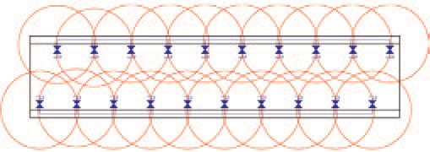
Dimensions - as on the schematic diagram of the water main system. The radius of every circle, R = 20 m.

Pp = H · ρ · g · 10-6 + ph
where :
+ ∆pstr
Fig. 1. Method of arranging the hydrant valves on the dock
(the authors’ original drawing).
The next phase is selection of pipe line diameters. Diameters

H – height from water level to the highest located ﬁre hydrant valve [m]
ρ – water density [kg/m3]
g – gravity acceleration [m/s2]
ph – water pressure before hydrant valve [MPa]
∆pstr – sum of pressure losses for the least favourably located valve.
The pressure before hydrant valve ph = 0.28 MPa was as- sumed in accordance with the requirements of the PRS Rules. Now only the sum of pressure losses for the least favourably
located valve remains for calculation. It consists of the losses resulting from friction drag of water ﬂow through piping as well as the losses resulting from local drag in piping elements. Therefore it is necessary to carry out hydraulic calculations on the basis of the schematic diagram of the system divided into sections; for each of them the calculations are performed separately and then their results are added together.
of particular kinds of pipe lines are chosen on the basis of the system’s schematic diagram by using the following formula :
D ≥ 9.4032 · Q0.5
where :
Q – maximum volumetric rate of water ﬂow through a given section of pipe line
at the assumed water ﬂow velocity w = 4 m/s .
Speciﬁcation of kinds of the pipe lines used
in the water ﬁre main system for the ecological dock

∆p = ρ [Σ (Σ ξ + λ · l /D ) w 2/2 + w 2/2] · 10-6
No. | Name of pipe line | Nominal diameter D [mm]
1 | The pipeline between the pump and water main | 90
2 | The vertical main pipe line for branch pipes leading to hydrant valves | 50
3 | The pipe line connecting the ﬁre systems in both dock’s side walls | 125

str
ij i i i i h
The pipes should be installed inside the side walls so as pre-

where :
ρ – water density [kg/m3]
Σ ξij – sum of local drag coefﬁcients in ith section
vent them against direct atmospheric exposure, a temperature below 0°C in particular. Non-heat resistant materials cannot be applied to the pipe lines unless they are suitably insulated. The pipe lines should be ﬁtted with draining equipment.

Speciﬁcation of elements of the designed water ﬁre main system

No. | Name | Number of pieces
1 | Main ﬁre pump (or ballast one) | 2
2 | Emergency ﬁre pump | 1
3 | Vertical pipe lines for branch pipes leading to hydrant valves, D = 50 mm | -
4 | Pipe line from ﬁre pump to water main, D = 90 mm | -
5 | The pipe line connecting the ﬁre systems in both dock’s side walls, D = 125 mm | -
6 | Φ52 hydrant valve | 74
7 | H52/20 hydrant hose | 38
8 | Hose nozzle of 19 mm outlet diameter | 38
9 | Hydrant hose box | 38
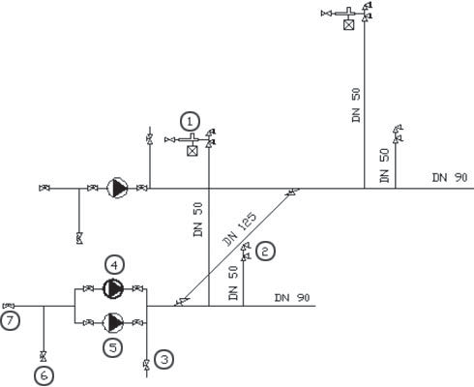
DN - nominal diameter [mm]
Fig. 2. Schematic diagram of the main elements of the designed water ﬁre main system for the ecological dock. (the author’s original drawing) Legend : 1 – ﬁre ﬁghting post for water and froth ﬁre-extinguishing – froth stub pipe, pipe line choke, frothing liquid tank, two hydrant valves;
2 – ﬁre ﬁghting post for water extinguishing - two hydrant valves;
3 – cut-off valve in pipe line to the right side wall ballast system (the same on the left side wall); 4 – ﬁre emergency pump; 5 – water ﬁre main pump for the right side wall (the same on the left side wall); 6 – kingston valve for water input to the right side wall (the same on the left side wall);
7 – cut-off valve for water input from a land-based water system, installed in the right side wall (the same on the left side wall).

The described method determines an algorithm of prelimi- nary designing the water ﬁre main system for the dock, applying a strict approach to ﬁre protection problems. In reality during design process many simpliﬁcations are possible to be applied under the consent of classiﬁcation society’s surveyor provided the designer has in his disposal a more exact information on real working conditions of the designed object.

Description of the froth ﬁre-extinguishing system designed for ﬁre protection
of the main deck area of the ecological dock
Decision on application of an additional ﬁre ﬁghting system is left to the designer, however in the PRS rules any arguments justifying it cannot be found. Nonetheless, the preliminary design calculations of such installation were performed as the versatile character of the dock was assumed. The dock in question should be ﬁtted with a permanent froth ﬁre-extingui- shing system for ﬁre protection of the dock’s main deck and a docked object because the possibility of docking the tankers whose systems are out of operation, has been assumed.
The application of the froth ﬁre-extinguishing system for docked objects is necessary in the case when various inﬂam- mable liquid substances are stored in them. This is rather inexpensive in the case of the designed ﬁre ﬁghting system because in the proposed type of froth ﬁre-extinguishing system the use has been made from some elements and the principle of work of the water ﬁre main system required by the rules. This way no large investments associated with its application are necessary.
In contrast to elsewhere proposed design solutions of ﬁre protection system for ecological dock the proved production method of a low-expansion froth by using pipeline choke, was selected. The designed froth ﬁre – extinguishing posts are arranged on the upper decks of both dock’s side walls, inside hydrant valve boxes. Every post is composed of the pipeline choke terminated in stub pipe with Φ52 universal root, and thefrothing agent tank connected to it. The pipeline choke is connec- ted to the water ﬁre main system and makes it possible – due to its construction – to produce a low-expansion froth smoothly.

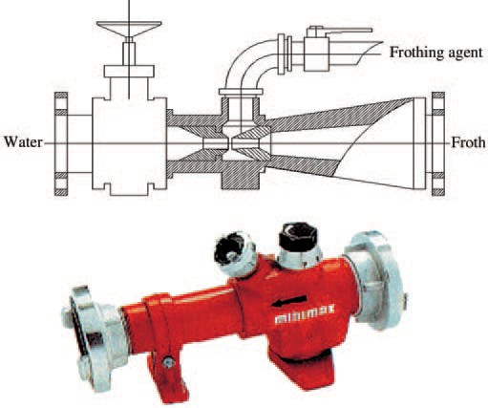
Fig. 3. Schematic diagram and photograph of pipeline choke (acc. Catalogue of products of MINIMAX Co.).
In this case the shown solution is the least expensive. More- over, under assumption that the froth ﬁre-extinguishing system is not equipped with ﬁre-ﬁghting monitors this solution would not require additional frothing agent pumps, that – in conse- quence – makes its reliability greater. Due to its simplicity the design system is versatile and makes it possible to adjust kind of froth to a particular ﬁre hazard. It seems to conﬁrm that : the simplest the best. Owing to application of the concept, to design any frothing agent tank is not necessary. Producers of frothing agents of the kind deliver them in ready-made tanks which are suitable for temporary installation on board the dock to be connected to pipe line chokes. This greatly simpliﬁes the process of supplementing amount of the frothing agent within the system, and generates next savings.

Calculations of main parameters of the designed froth ﬁre-extinguishing system

A low-expansion froth of the expansion ratio Ls = 8 ÷12 was assumed as the ﬁre-extinguishing medium applied in the froth ﬁre-extinguishing system for the dock. Froths of the kind
are used to extinct ﬁres of inﬂammable liquids. In this design also possible work of the installation by using various frothing agents is assumed. By adjusting the choke individual selection of concentration of frothing agent in the mixture is possible.

The speciﬁc consumption of 6% frothing agent is:
Q = 0.06 (F · c)
where :
F = 3000 m2 - deck area of the largest ship possible to be docked ( with some margin)
c = 0.6 dm3/min·m2 – average froth delivering rate for the entire deck of docked object :

Q = 108 dm3/min
The required standard amount of stored frothing agent (together with a surplus) for ﬁre extinction within
the standard time t :
Qc = t · Q
where :
t = 30 min – standard time of ﬁre-extinguishing
Qc = 3240 dm3
The required standard amount of stored frothing agent for particular ﬁre froth-extinguishing posts and selection of capa- city of the tanks installed at the ﬁre ﬁghting posts :

as required : V = 180 dm3 – as assumed : Vzb = 200 dm3 Water delivery rate from the ﬁre main system,
required for operation of the ﬁre froth-extinguishing system :

Qw = F · c · [(100% - 6%) / 100%] =
= 1.80 m3/min (108 m3/h)
An alternative concept of the froth ﬁre-extinguishing system is the solution consisting in application of froth monitors to deliver froth to a protected area. The solution provides some advantages resulting from the possibility of more favourable froth streams manoeuvring, as compared with the above con- sidered one. However the solution is much more expensive and complicated. The differences results ﬁrst of all from the necessity of application of frothing agent pumps , additional pumps delivering water to the system, or designing a pipe line to connect the system with a land water source.

Calculations of main parameters of ﬁre froth-extinguishing system equipped with froth monitors

The speciﬁc consumption of 6% frothing agent – under assumption that the deck area of docked object is ﬁre-protected with the use of froth monitors :

Q = 0.06 · (F · c)
where :
F = 3000 m2
c = 3 dm3/min·m2 – average rate of froth delivering onto the entire deck area of docked object
in the case of application of froth monitors :

Q = 540 dm3/min
The required standard amount of stored frothing agent (together with a surplus) for ﬁre extinction
within the standard time t :
Qc = t · Q
where :
t = 30 min – standard time of ﬁre extinguishing.
Qc = 16200 dm3
Capacity of frothing agent tank with the assumed 5% surplus :

V = 17 m3
Capacity of froth agent pumps :
Qp = 1.25 · Q = 675 dm3/min (40.50 m3/h) Total capacity of water supply pumps for the ﬁre froth-extinguishing system ﬁtted with froth monitors :
Qw = 507.60 m3/h
In the case if two froth monitors are assumed the calculated capacity values of frothing agent and water pumps have to be divided by two.

Description of the designed CO2 -
- smothering system intended for the protection of engine room, workshop, electric switching station and cable duct
In the PRS Rules for the Classiﬁcation and Construction of Floating Docks the necessity of application of a CO2 -
- smothering system for the protection of such compartments
as engine rooms, cable ducts etc located on the dock, is not clearly stated. The mentioned compartments are not required to be attended though they contain many ﬁre hazardous objects in engine room, electric switching station, workshop and cable duct between dock’s side walls such as e.g. electric genera- ting sets , electric switchboards and cables hence their risk to ﬁre is much greater as compared with other compartments. Possible ﬁre in any of the above mentioned compartments could be detected too late. It seems that this is sufﬁcient re- ason to consider application of an automatic volumetric ﬁre extinction system for those compartments. The volumetric ﬁre extinction method consists in ﬁlling a protected space with a gas medium not supporting the combustion process. Therefore during designing the systems of the kind special attention should be paid to correct assessment of volume of a given protected space.
„The rated volume of protected space V – gross volume
of the protected space limited by water-tight or gas-tight bulk- heads, walls and decks, without any deduction for volume of structural elements and equipment contained therein” (accor- ding to the PRS Rules for the Classiﬁcation and Construction Sea-going Ships, Part V p. 1.2 ).

Calculation principles for parameters
of main elements of CO2 - smothering systems
The most classical solution of volumetric ﬁre extinction system is the application of CO2 - smothering one. For the ecological dock in question a CO2 high pressure system (using
gas cylinders ) designed with the use of standardized elements
offered by ANSUL INC, was proposed.
The designing procedure for such system consists in :
➲ ﬁnding the correct location of CO2 extinction station
➲ calculation of a required amount of ﬁre-extinguishing medium
➲ choice of solution for triggering the system working, and
➲ choice of parameters of CO2 distributing pipe lines, as well as other components of the system.

The designed system is intended for ﬁre protection of the following spaces of the dock

No. | Name of space | Capacity (volume) [m3] | Percentage volumetric ratio relative to the largest one
1 | Compartment of electric generating sets | 160 | 50 %
2 | Electric switching station | 320 | 100 %
3 | Workshop | 80 | 25 %
4 | Cable duct together with vertical casings | 312 | 98 %
According to the PRS Rules the required amount of carbon dioxide for ﬁre-extinguishing systems should be calculated with the use of the following formula :
G = 1.79 · V · ϕ
where :
V – rated volume of the largest space to be protected [m3]
ϕ – compartment ﬁlling ratio, ϕ = 0.35 – for engine rooms whose total volume is determined with accounting for volume of casings.

G = 200.48 kg
Carbon dioxide for such systems is stored in cylinders. To calculate a number of CO2 cylinders located in the CO2 ﬁre extinction station the following formula should be applied :

n = G/V_{zb} · β
where :
G – amount of carbon dioxide for protection of a given space (compoartment) [kg] Vzb – capacity of CO2 cylinders [dm3]
β – ﬁlling ratio of CO2 cylinders [kg/dm3].
The capacity of CO2 cylinders, Vzb = 67.5 kg was obtained on the basis of a design handbook for high-pressure CO2 smo- thering systems, published by ANSUL Inc.
The ﬁlling ratio of CO2 cylinders, β ≤ 0.675 kg/dm3 at the rated cylinder pressure p ≥ 12.5 MPa, was assumed in accor- dance with the PRS Rules.
Number of cylinders, n = 4.4 was obtained from the calcu- lations hence by rounding up 5 CO2 cylinders of ANSUL Inc. production, were ﬁnally assumed.
The next phase of designing is to decide where CO2 ﬁre

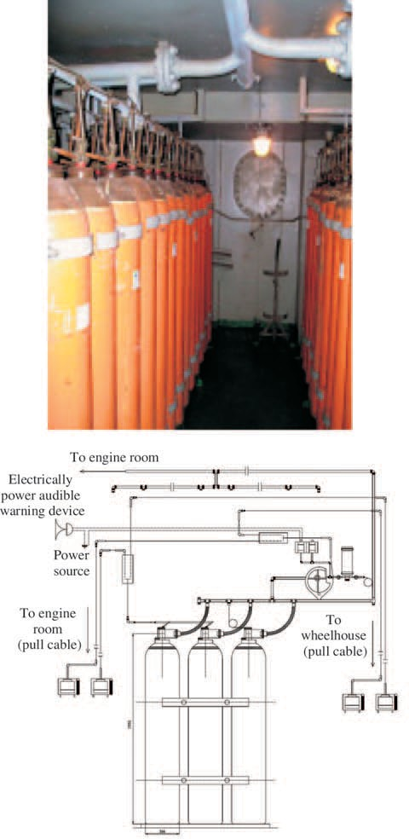
Fig. 4 and 5. Photographs and schematic diagrams of the local CO2 - smothering system for ﬁre protection
of the emergency electric generating set.
Choice of pipe line diameters for CO2 - smothering sys-

extinction station has to be located. In accordance with the rules of classiﬁcation societies such stations should be located on open decks. Moreover they should be separated from adjacent compartments with gas-tight decks and walls. Thermal insula- tion should be provided so as to ensure a positive temperature inside the station.
In the course of designing of such small CO2 - smothering systems the designer should decide whether the designed system has to serve for local or total ﬁre protection purposes. In the case
in question the second variant should be accepted as the dock’s machinery compartments and cable duct are unattended.
Photographs and schematic diagrams of the local CO2 -
- smothering system are presented in Fig. 4 and 5.
Currently, producer of ﬁre protection systems makes a com- plete catalogue of system components available to the designer. However majority of producers stipulates that only original components made by a given producer have to be applied. The- refore the role of the designer in selecting particular elements for a ﬁre protection system has become very limited.
tems consists in making use of the following principle given in the PRS Rules :
d2 ≥ di2
∑
and
d2/m = di2/mi
where :
d – inlet pipe line diameter equal to sum of all cross-
-sectional areas of cylinder valves [mm] di – i-th branch pipe line diameter [mm]
m – mass of CO2 amount which has to be delivered
through the inlet pipe line [kg]
mi – mass of CO2 amount which has to be distributed through the i-th branch pipe line [kg].
The cross-sectional area
of ANSUL GV97 cylinder valve is :
Dz = 20 mm

Diameters of the pipe lines leading to particular compart- ments were calculated by using the following formula and schematic diagram :
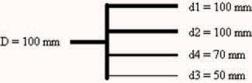
to electric switching station to cable duct
to dock’s engine room
to workshop

Fig. 6. Auxiliary schematic diagram for calculation of pipe line diameters of CO2 - smothering system intended for the ecological dock in question.
Calculations of the parameters of another components have been omitted as they are of a minor importance in the course of conceptual designing the CO2 - smothering system.
The CO2 - smothering system can cooperate with ﬁre de- tection and warning systems. In such case the ﬁre extinction
procedure is controlled by an approved central ﬁre extinction station. The relevant procedure may approximately proceed in the following steps :
- detection of a ﬁre automatically by a ﬁre detector, or by pushing a button of manual ﬁre alarm
- activation of time-delay counting to make a check, and pos- sible immediate extinction of a ﬁre in one of the protected compartments, and in the same time automatic switching-
-off the ventilating systems in these compartments, and switching-in the audible ﬁre warning alarm
- after ending the time-delay counting or intentional cutting-
-off the time delay by an operator, starting the system of sealing all openings in the endangered compartment
- starting the ﬁre extinction system.
For safety reasons such procedure should be always determined and strictly obeyed.
The presented design and associated calculations represent only one of the possible variants of ﬁre protection system for the ecological dock designed in the frame of “EUREKA” project. Only an analysis of several elaborations of the kind makes it possible to choose an optimum solution. It seems to be many possible variants of ﬁre protection system for the dock since its designer has a wide room for decision making in this respect. An intention of the designer of the described concept was to present the most practically realizable set of technical solutions
applicable to the ﬁre protection system for ﬂoating docks.

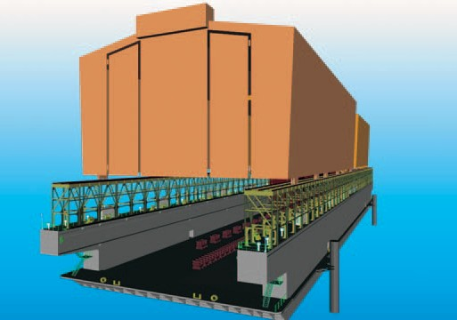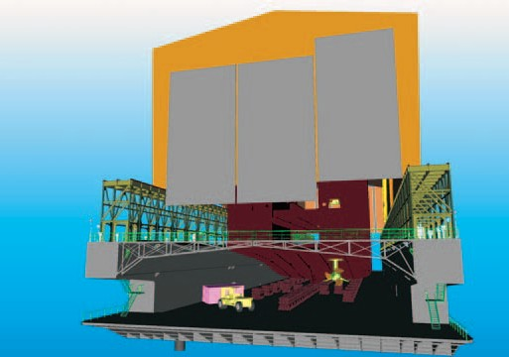
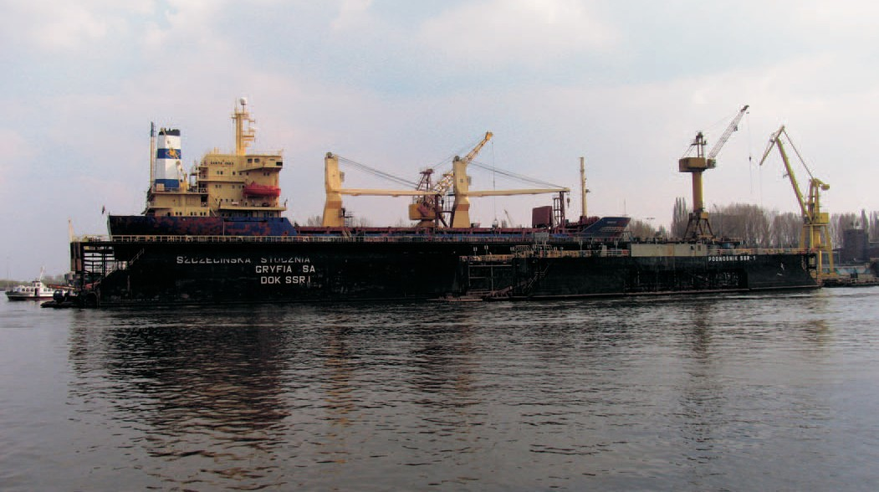
Photo : Cezary Spigarski

